**Ex 1 ADVANCED LINUX COMMANDS**

**Date: 18.08.20**

**Aim:**

To study and implement the linux commands

**Description:**

|  |  |  |  |
| --- | --- | --- | --- |
| **Sl. No.** | **Command Name** | **Meaning** | **options** |
| 1. | **ls** | List files and/ordirectories. | -a, --all  do not ignore |
|  |  |  | entries starting with . |
|  |  |  | -A, --almost-all |
|  |  |  | do not list |
|  |  |  | implied .and .. |
|  |  |  | --author |
|  |  |  | with -l, print the |
|  |  |  | author of each file |
|  |  |  | -b, --escape |
|  |  |  | print C-style |
|  |  |  | escapes for nongraphic |
|  |  |  | characters |
|  |  |  | --block-size=SIZE |
| 2. | **Who am i** | This command reveals the user who is currently logged in. | -a, --all =same as -b -d -- login -p -r -t -T -u  -b, --boot  time of last system boot  -d, --dead  print dead processes -H, --heading  print line of column headings  -l, --login  print system login processes  --lookup  attempt to canonicalizehostnames via DNS |
| 3. | **pwd** | prints the absolute path to current working directory | -L, --logical  use PWD from environment, even if it contains symlinks  -P, --physical  avoid all symlinks |
| 4. | **cal** | Displays the calendarof the current month | -1, --one  Display single  month output. (This is  the default.)  -3, --three  Display  prev/current/next  month output.  -s, --sunday  Display Sunday  as the first day of the  week.  -m, --monday  Display Monday  as the first day of the  week.  -j, --julian  Display Julian  dates (days one-based,  numbered from January   1. -y, --year |
| 5. | **echo** | This command will echo whatever you provide it. | -n do not output the trailingnewline  -e enable interpretation of backslashescapes  -E disable interpretation of backslash escapes (default) |
| 6. | **date** | Displays current time and date. | -d, --date=STRING  display time described by STRING, not 'now'  -f, --file=DATEFILE  like --date once for each line of DATEFILE |
| 7. | **tty** | Displays currentterminal. |  |
| 8. | **id** | This command prints user and groups (UID and GID) of the  current user. | -a ignore, for compatibility with other versions  -Z, --context  print only the  security context of the  current user  -g, --group  print only the  effective group ID  -G, --groups  print all group  IDs  -n, --name  print a name instead of a number, for  -ugG |
| 9. | **clear** | This command clearsthe screen. |  |
| 10. | **man** | To show manual page |  |
| 11. | **cd** | Change the current working directory to the directory provided  as argument. |  |
| 12. | **mkdir** | To create a directory, the ‘mkdir’ commandis used. |  |
| 13. | **touch** | For creating an empty file, use the touchcommand. |  |
| 14. | **cp** | Copy files anddirectories |  |
| 15. | **mv** | Move files or directories. The 'mv' command works like 'cp' command, except that the original file is removed. But, the mv command can be used to rename the files (or  directories). |  |
| 16. | **rmdir** | command removes any empty directories, but cannot delete a directory if a file is  present in it. |  |
| 17. | **file** | The file commanddetermines the file type of a given file. |  |
| 18. | **cat** | The 'cat' command is  actually a concatenator but can be used to view the  contents of a file. |  |
| 19. | **head** | Displays the first few lines of a file. By default, the ‘head’ command displays the first 10 lines of afile. |  |
| 20. | **tail** | the ‘tail’ command shows the last 10 lines by default | -c, --bytes=[-]K  print the first K bytes of each file  -n, --lines=[-]K  print the first K lines instead of the first 10  -q, --quiet, --silent  never print headers giving file names |
| 21. | **wc** | This command counts lines, words and letters of the input  given to it. |  |
| 22. | **grep** | The ‘grep’ command searches for a pattern in a file (or standard  input). |  |
| 23. | **vi** | Visual editor |  |
| 24. | **alias** | The ‘alias’ is anothername for a command. |  |
| 25. | **history** | shows the commands you have enteredonyour terminal sofar. |  |
| 26. | **passwd** | To change yourpassword |  |
| 27. | **help** | With almost every command, ‘--help’  option shows usage summary for thatcommand. |  |
| 28. | **chmod** | The *chmod*command lets you change access permissions for a file. |  |
| 29. | **stat** | To check the status of a file. This provides more detailed information about a file than ‘ls -l’ output. | -L, --dereference  follow links  -f, --file-system  display file system status instead of file status  -c --format=FORMAT use the  specified FORMAT instead of the default; output a newline after each use of FORMAT  --printf=FORMAT |
| 30. | **ln** | command is used inlinux to create links. |  |

**Exercise**

1. **List the contents of user's home directory including the hidden files**

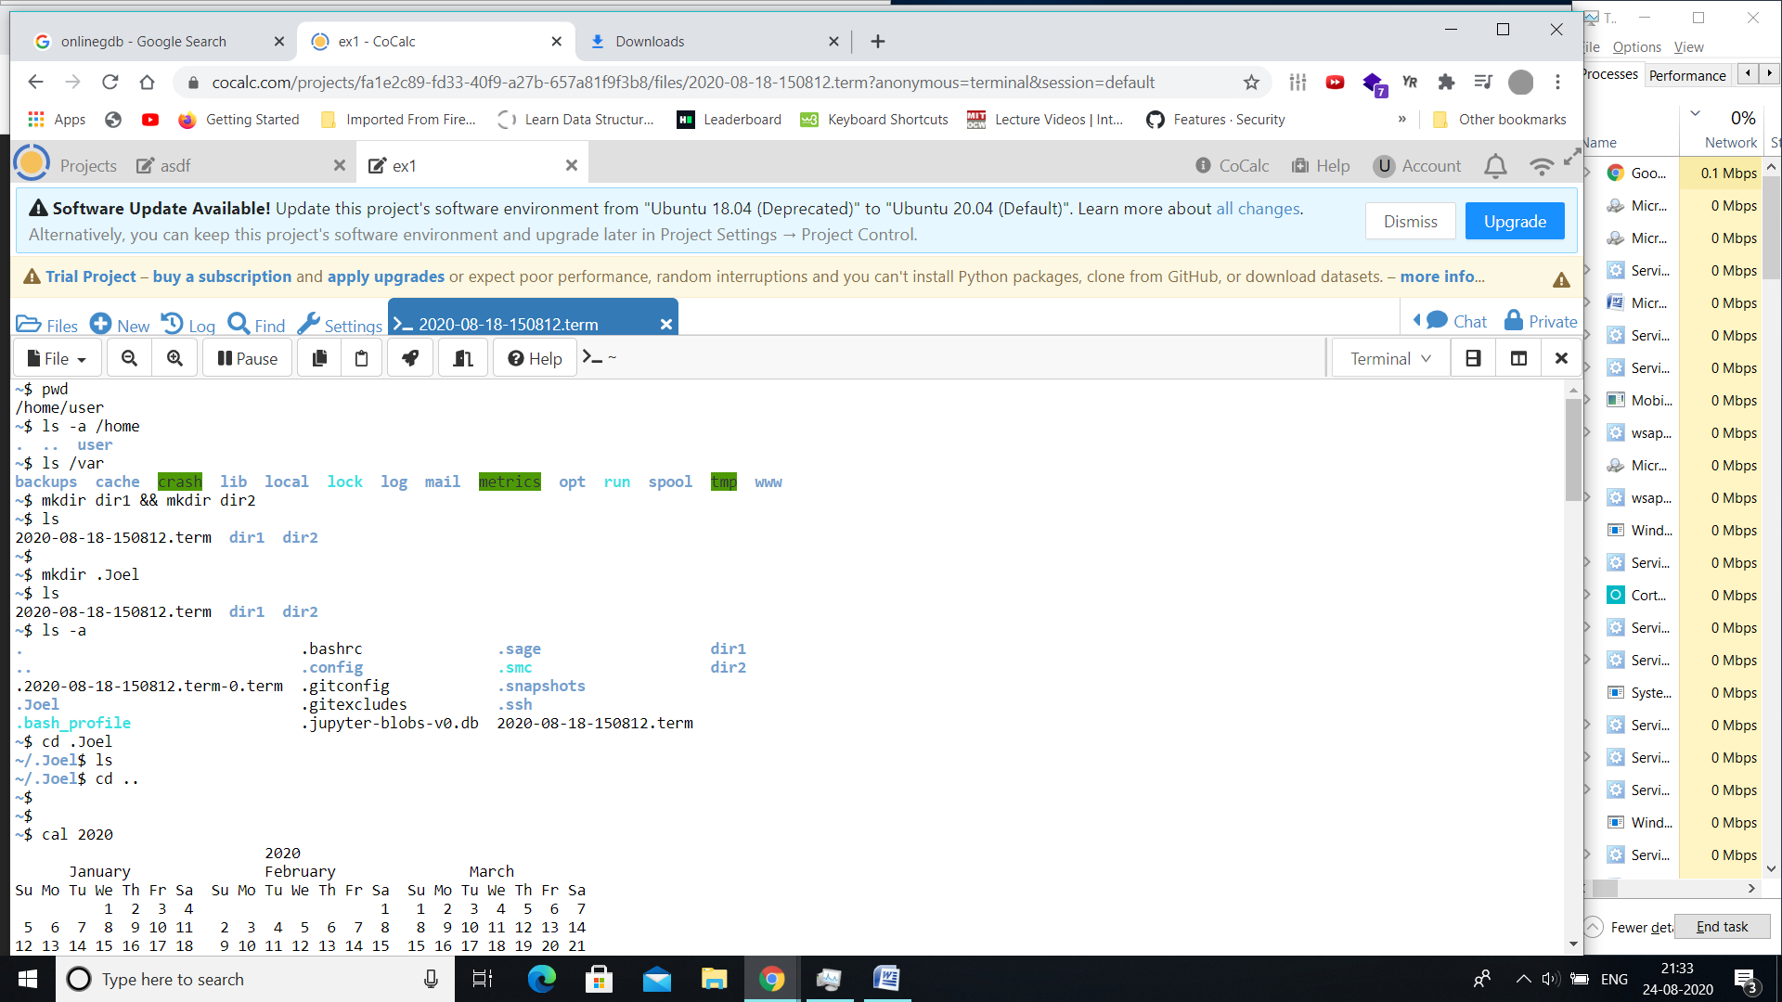

1. **List the content of /var directory?**

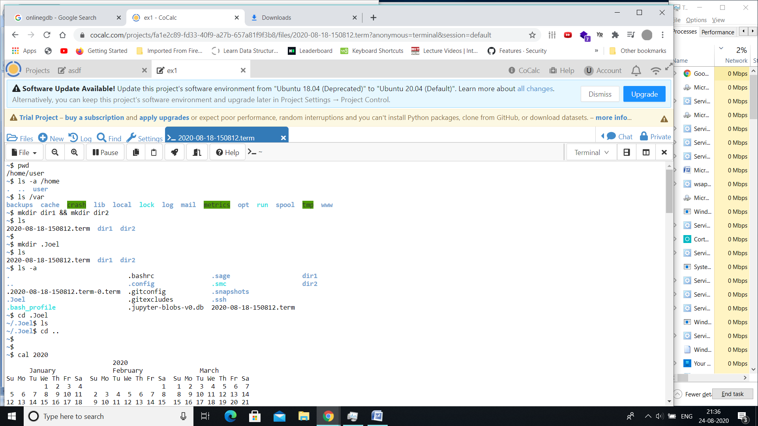

1. **Create two directories named dir1 & dir2**



1. **Create a hidden directory with your name?**



1. **Display the content of a hidden directory.**



1. **Display the calendar of 2020.**

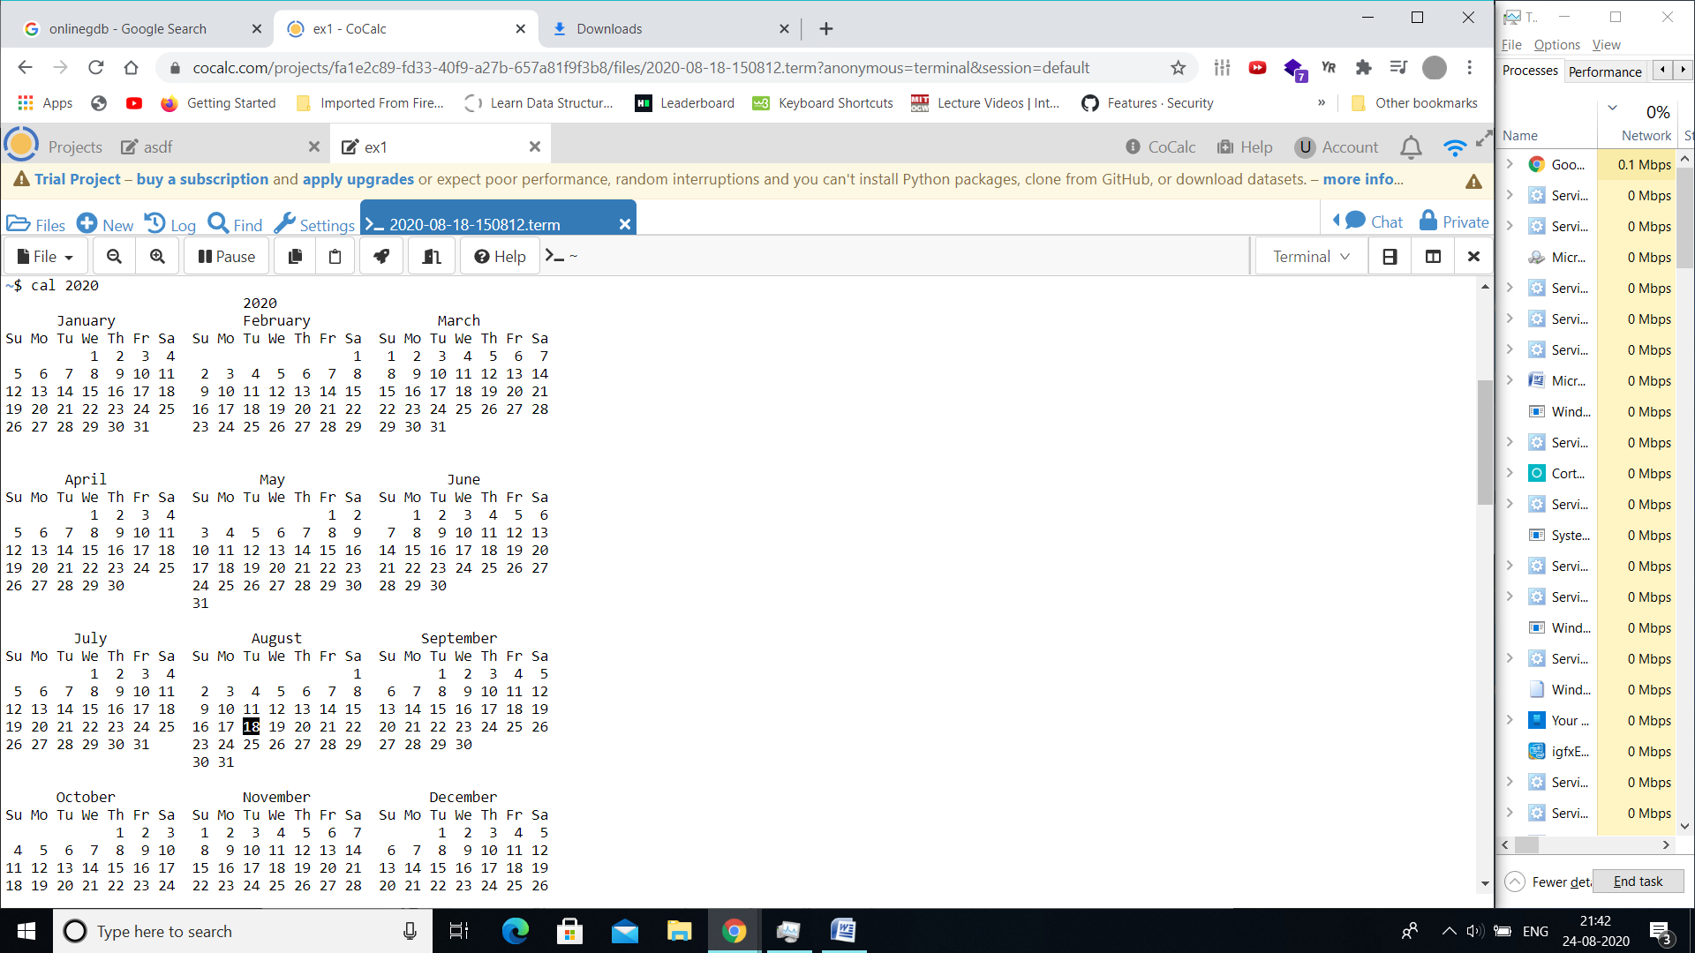

1. **Copy the file /etc/passwd file to current directory with sample.txt as the filename.**

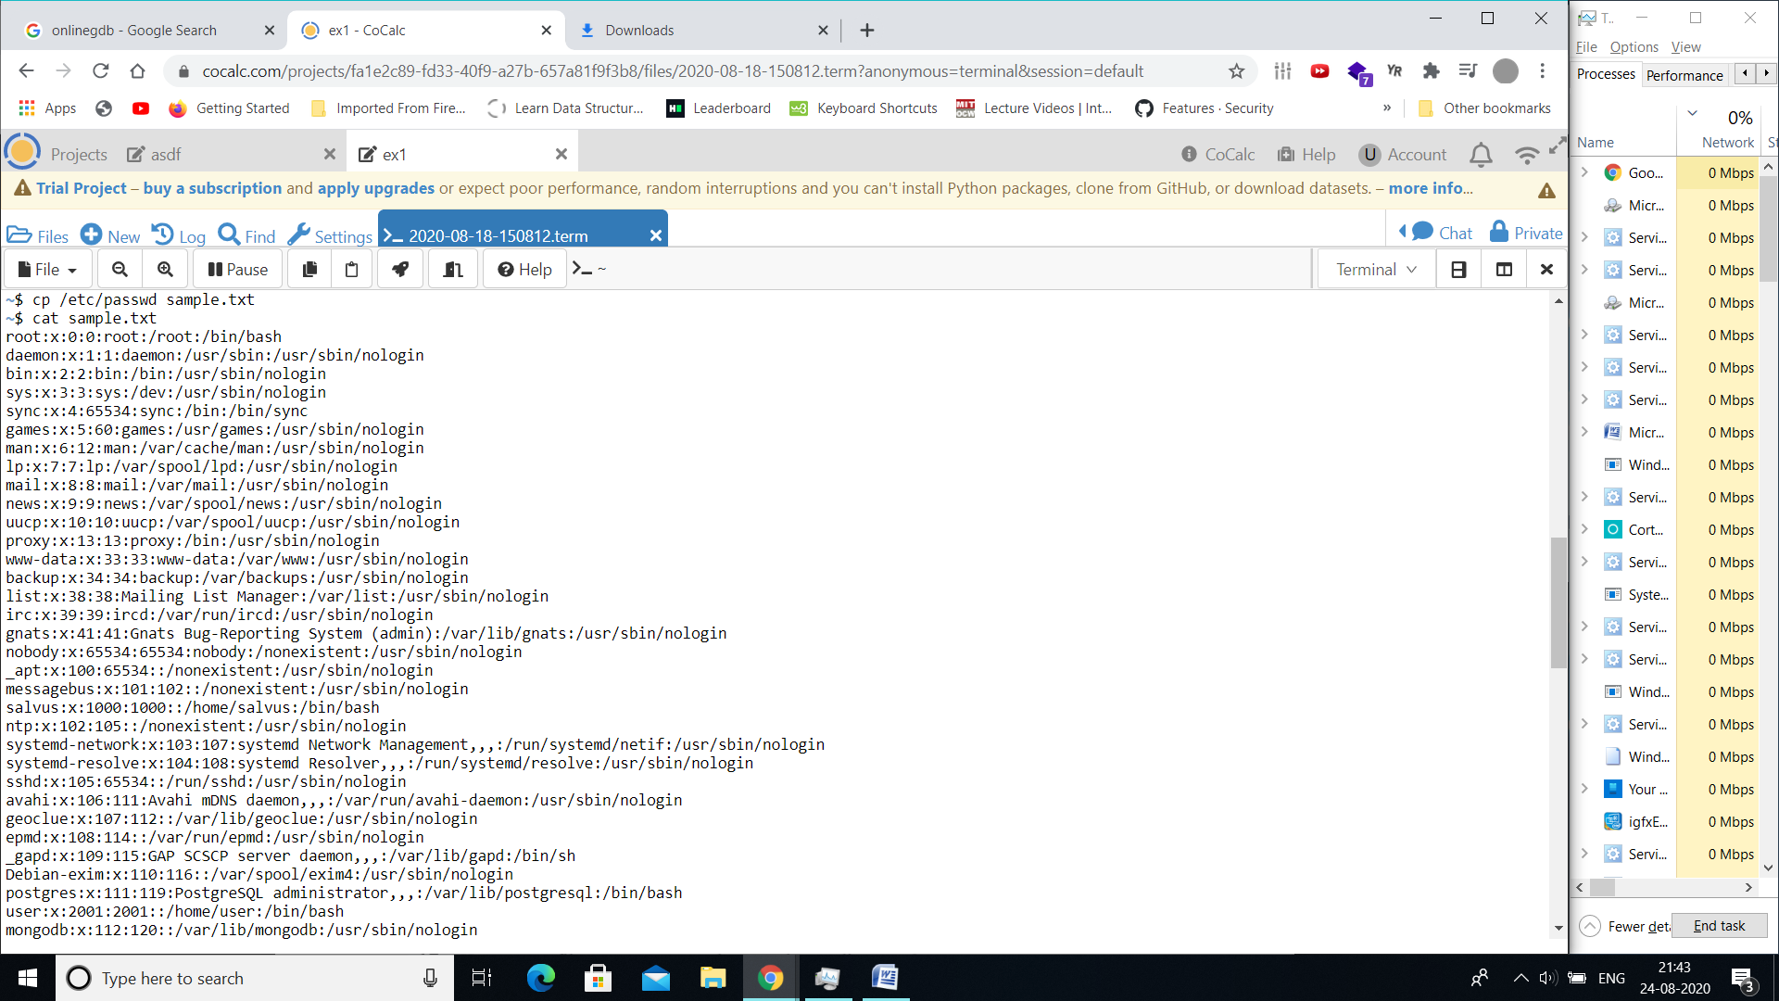

1. **Create a file test1.txt using Vim editor with the following contents to it.**
   1. **Display the student names who are having Research Interest as Grid Computing.**



* 1. **List all the student names & RegNo in the class**

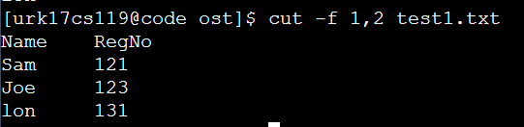

* 1. **List the count of students who have interest as Image Processing and store the result in another file.**



* 1. **Display the first two rows and last two and store into another file**

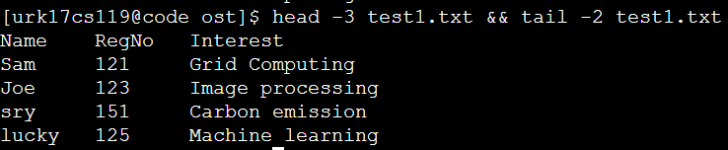

1. **Display the contents of the file test1.txt without any blank lines**

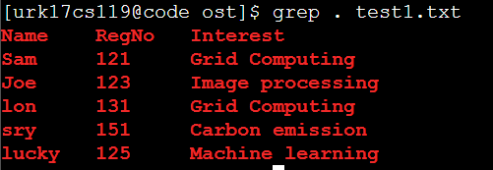

1. **Move the file sample.txt from dir1 directory to dir2 directory**

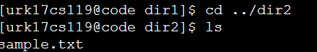

1. **Change directory into dir2 directory**



1. **Check whether the file sample.txt is present their**
2. **Rename the file sample.txt to new.txt and check whether sample.txt is there or not?**

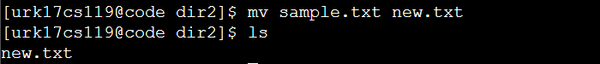

1. **Remove the directory dir1**



1. **Display last 3 lines of the file test1.txt**

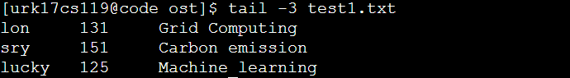

1. **Display all the commands you have executed so far and save the list into a file named todayshistory.txt**

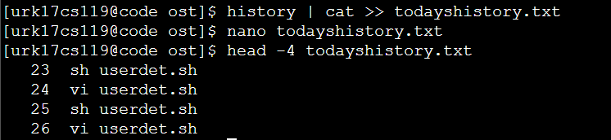

1. **How many files are present under your home directory?**



1. **Perform sorting of three files and store the sorted file in the fourth file**

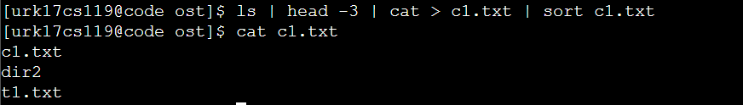

1. **Change the permission of your newly created file such that the group users and others don’t access any type of access.**

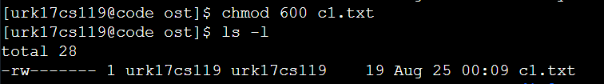

1. **Display the network status on the shell.**

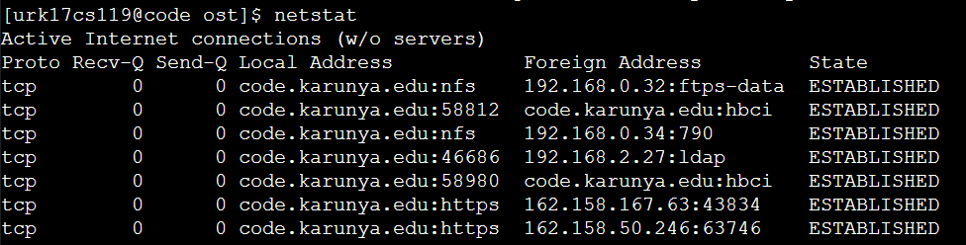

1. **Compares any two files and search for both common and exclusive features**

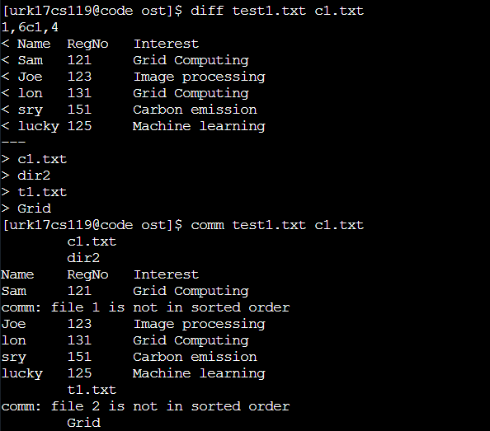

1. **Display the user ID, process ID and parent process ID.**



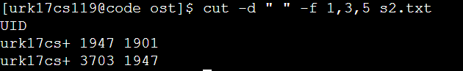

1. **Report disk usages of file system.**

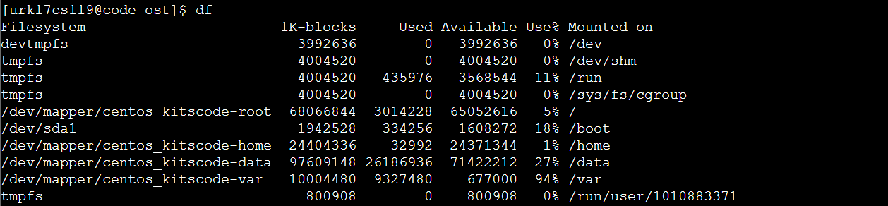

1. **Display the statistics of all ports connected to a network.**

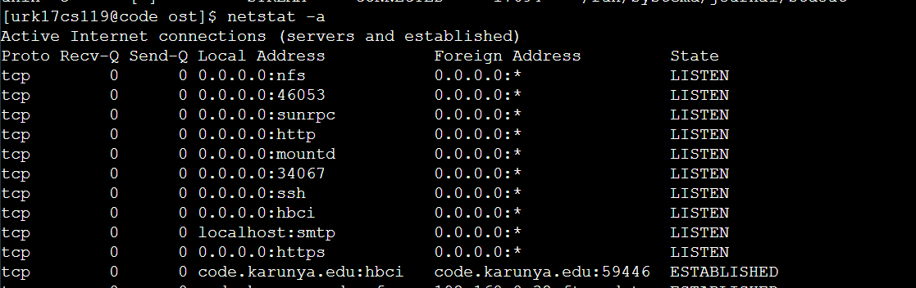

1. **Display the uptime of the system and show the statistics of memory usage. Check if there is any malicious packets intrude the network**





1. **Display Julian date**

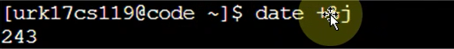

1. **Check if Linux platform is infected over network**

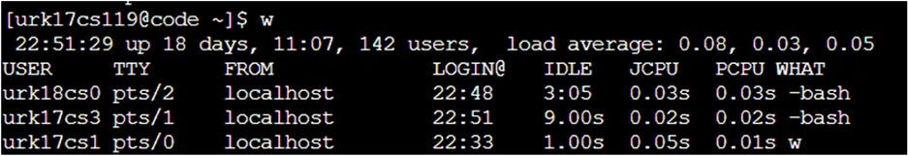

1. **Display free space available in shell memory**

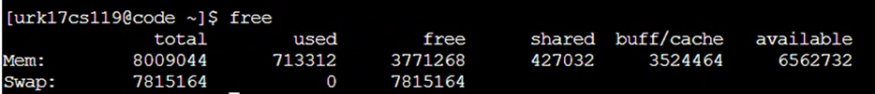

1. **Display configuration info of your network**

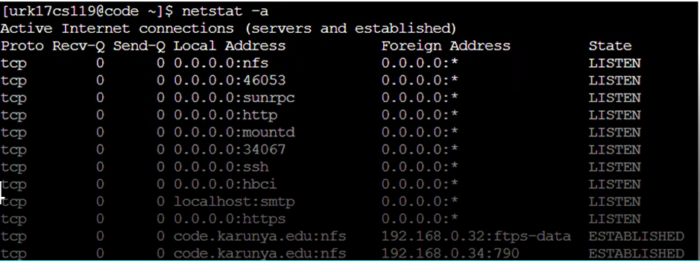

1. **Display IP configuration**

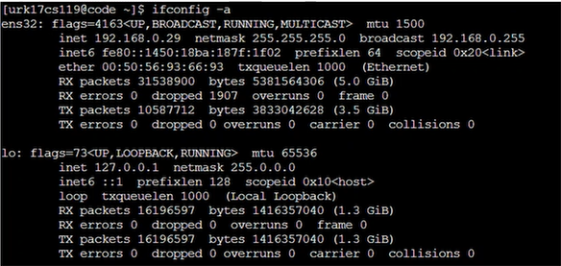

**Youtube Link:** [**https://youtu.be/OJV0BkaImXA**](https://youtu.be/OJV0BkaImXA)

**Results:**

The linux commands are studied and executed.